**Bajaj Allianz General Insurance Co. Ltd.**

Bajaj Allianz House, Airport Road, Yerwada, Pune – 411006. Reg.: 113 | CIN: U66010PN2000PLC015329 For more details, log on to : [www.bajajallianz.com](http://www.bajajallianz.com/)

**Email** [**id**:-customercare@bajajallianz.co.in](mailto:-customercare@bajajallianz.co.in) **Toll free no:**1800-209-5858

020-30305858 (To be filled in block letters)

### CLAIM FORM FOR HEALTH INSURANCE POLICIES OTHER THAN TRAVEL AND PERSONAL ACCIDENT – PART A

TO BE FILLED IN BY THE INSURED

The issue of this form is not to be taken as an admission of liability

# DETAILS OF PRIMARY INSURED

a) Policy No: b) Sl. No

|  |  |  |  |  |  |  |  |  |  |  |  |  |  |  |  |  |  |  |  |  |  |  |  |
| --- | --- | --- | --- | --- | --- | --- | --- | --- | --- | --- | --- | --- | --- | --- | --- | --- | --- | --- | --- | --- | --- | --- | --- |
|  |  |  |  |  |  |  |  |  |  |  |  |  |  |  |  |  |  |  |  |  |  |  |  |
|  | | |  |  |  |  |  |  |  |  |  |  |  |  |  |  |  |  |  |  | | | |

|  |  |  |  |  |  |  |  |  |  |
| --- | --- | --- | --- | --- | --- | --- | --- | --- | --- |
| /Certificate No: | | | |  |  |  |  |  |  |
|  |  |  |  |  |  |  |  |  |  |

c) Company TPA ID No: d) Customer ID:

e) Company Name: f) Employee No:

1. Name:

|  |  |  |  |  |  |  |  |  |  |  |  |  |  |  |  |  |  |  |  |  |  |  |  |  |  |  |  |  |  |  |  |  |  |  |  |  |
| --- | --- | --- | --- | --- | --- | --- | --- | --- | --- | --- | --- | --- | --- | --- | --- | --- | --- | --- | --- | --- | --- | --- | --- | --- | --- | --- | --- | --- | --- | --- | --- | --- | --- | --- | --- | --- |
|  |  |  |  |  |  |  |  |  |  |  |  |  |  |  |  |  |  |  |  |  |  |  |  |  |  |  |  |  |  |  |  |  |  |  |  |  |
|  |  |  |  |  |  |  |  |  |  |  |  |  |  |  |  |  |  |  |  |  |  |  |  |  |  |  |  |  |  |  |  |  |  |  |  |  |

1. Address:

City: State: Pin Code:

Phone No: Email ID:

# DETAILS OF INSURANCE HISTORY

1. Currently covered by any other Mediclaim / Health Insurance Yes No
2. date of commencement of first insurance without break
3. If yes, company name: Sum Insured (Rs.):

|  |  |  |  |
| --- | --- | --- | --- |
| Y | Y | Y | Y |

Policy No:

1. Have you been hospitalized in the last four years since inception of the contract? Yes No Date:

Diagnosis

1. Previously covered by any other Mediclaim / Health Insurance: Yes No
2. If yes, Company Name

D D M M

# DETAILS OF INSURED PERSON HOSPITALIZED

1. Name of the Patient:
2. Health ID card no of the Patient:

|  |  |  |  |
| --- | --- | --- | --- |
| Y | Y | Y | Y |

1. Gender: Male Female d) Age: years

months e) Date of Birth

## D D M M

1. Relationship of Primary insured: Self Spouse Child Father Mother Other (Please Specify)
2. Occupation: Service Self Employed Homemaker Student Retired Other (Please Specify)
3. Address (if different from above) City: State: Pin Code:
   1. Phone No: J) Email ID:

# DETAILS OF HOSPITALIZATION

* + 1. Name of Hospital where Admitted:
    2. Room Category occupied: Day Care Single occupancy Twin sharing 3 or more beds per room
    3. Hospitalisation due to: Injury Illness Maternity

|  |  |  |  |
| --- | --- | --- | --- |
| Y | Y | Y | Y |

* + 1. Date of Injury/Date Disease first detected/Date of Delivery:

|  |  |  |  |
| --- | --- | --- | --- |
| Y | Y | Y | Y |

## D D M M

* + 1. Date of admission D D M M
    2. Time: H H : M M
    3. Date of Discharge D D M M
    4. Time: H H M M
       1. Name of treating doctor Diagnosis



SECTION A

SECTION B

SECTION C

SECTION D

|  |  |  |  |
| --- | --- | --- | --- |
| Y | Y | Y | Y |

1. If injury give cause: Self inflicted Road Traffic Accident Substance Abuse /Alcohol Consumption
2. If Medico legal: Yes No ii) Reported to police: Yes No

iii) MLC report and Police FIR attached: Yes No j) System of Medicine

# DETAILS OF CLAIM

1. Details of the treatment expenses claimed

I. Pre-Hospitalisation Expenses: Rs. ii. Hospitalisation Expenses Rs.

iii. Post-Hospitalisation Expenses: Rs. iv. Health checkup cost Rs.

v. Ambulance Charges: Rs. vi. Others (code) Rs. Total Rs.

|  |  |  |  |  |  |  |
| --- | --- | --- | --- | --- | --- | --- |
|  |  |  |  |  |  |  |
|  |  |  |  |  |  |  |
|  |  |  |  | | | |

vii. Pre-Hospitalisation period: days viii. Post Hospitalisation period: days

1. Claim for Domiciliary Hospitalisation: Yes No (If yes, provide details in annexure)
2. Details of Lump sum / cash benefit claimed:

i. Hospital Daily Cash Rs. ii. Surgical Cash Rs.

iii. Critical illness Benefit Rs. iv. Convalescence Rs.

v. Pre/Post hospitalisation Rs. vi. Others Rs. lump sum benefit

Total Rs.

### Claim Documents Submitted – Check List

|  |
| --- |
|  |
|  |
|  |

Claim Form Duly Signed Original Hospital Breakup Bill Operation Theater Notes

|  |
| --- |
|  |
|  |
|  |
|  |

Copy of claim intimation if any Original Hospital Bill Payment Receipt ECG

Original Hospital Main Bill

Original Hospital Discharge SummaryPharmacy Bill Original Doctor's Prescriptions

|  |
| --- |
|  |
|  |
|  |
|  |

Original Doctors request for investigation reports (including CT/MRI/USG/HPE) Others

SECTION E

SECTION F

SECTION G

SECTION H

Cancelled blank cheque leaf with payee name printed. If name of the payee is not printed on the cheque leaf please attach copy of the first page of the bank passbook.

# DETAILS OF BILLS ENCLOSED

|  |  |  |  |  |  |  |  |  |  |  |  |  |  |  |  |  |
| --- | --- | --- | --- | --- | --- | --- | --- | --- | --- | --- | --- | --- | --- | --- | --- | --- |
| Sr.No | Bill No | Date | | | | | | Issued by | Towards | Amount (Rs) | | | | | | |
| 1 |  | D | D | M | M | Y | Y |  | Hospitalisation Main Bill |  |  |  |  |  |  |  |
| 2 |  | D | D | M | M | Y | Y |  | Pre-Hospitalisation Bills: Nos |  |  |  |  |  |  |  |
| 3 |  | D | D | M | M | Y | Y |  | Post-Hospitalisation Bills: Nos |  |  |  |  |  |  |  |
| 4 |  | D | D | M | M | Y | Y |  | Pharmacy Bills |  |  |  |  |  |  |  |
| 5 |  | D | D | M | M | Y | Y |  |  |  |  |  |  |  |  |  |
| 6 |  | D | D | M | M | Y | Y |  |  |  |  |  |  |  |  |  |
| 7 |  | D | D | M | M | Y | Y |  |  |  |  |  |  |  |  |  |
| 8 |  | D | D | M | M | Y | Y |  |  |  |  |  |  |  |  |  |
| 9 |  | D | D | M | M | Y | Y |  |  |  |  |  |  |  |  |  |
| 10 |  | D | D | M | M | Y | Y |  |  |  |  |  |  |  |  |  |

**DETAILS OF PRIMARY INSURED'S BANK ACCOUNT**

1. Name of the Account Holder ( As per Bank Account):
2. Account no ( As appearing in the cheque book):
3. Bank Name :
4. Branch Name & Address: :
5. Account Type : Saving Current Cash Credit
6. MICR No. g)IFSC Code:

|  |  |  |  |  |  |  |  |  |  |  |  |
| --- | --- | --- | --- | --- | --- | --- | --- | --- | --- | --- | --- |
|  |  |  |  |  |  |  |  |  |  |  |  |
|  |  |  |  |  |  |  |  |  |  |  |  |

h) PAN: i) Cheque / DD Payable Details:

**DECLARATION**

I hereby declare that the information furnished in this claim form is true & correct to the best of my knowledge and belief. If I have made any false or untrue statement, suppression or concealment of any material fact with respect to questions asked in relation to this claim, my right to claim reimbursement shall be forfeited. I also consent & authorize Bajaj Allianz General Insurance Company Limited, to seek necessary medical information / documents from any hospital / Medical Practitioner who ha s attended on the person against whom this claim is made. I hereby declare that I have included all the bills / receipts for the purpose of this claim & that I will not be making any supplementary claim except the pre/post-hospitalization claim, if any.

Date: Place: Signature of the Insured

D D M M

|  |  |  |  |
| --- | --- | --- | --- |
| Y | Y | Y | Y |

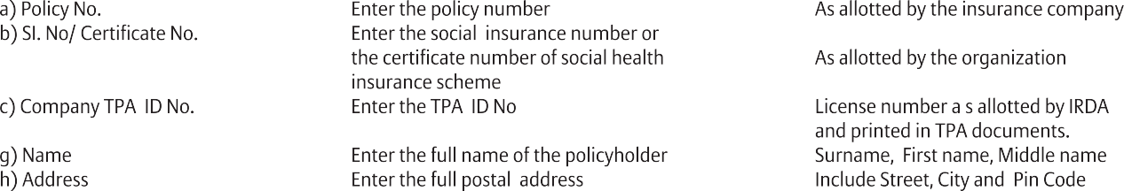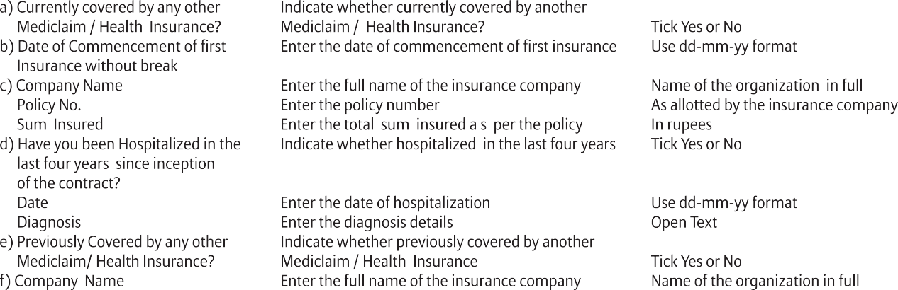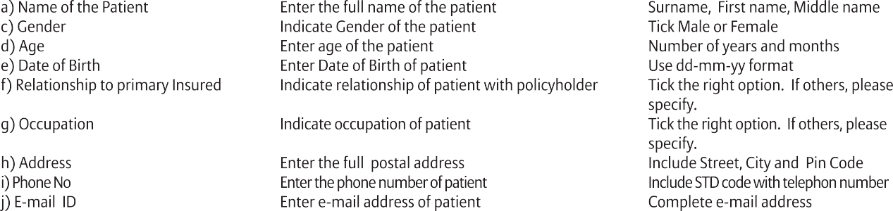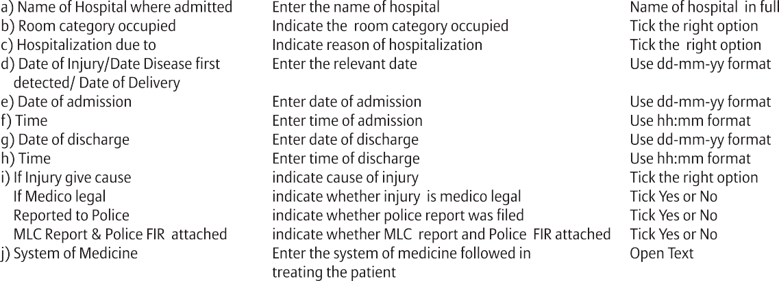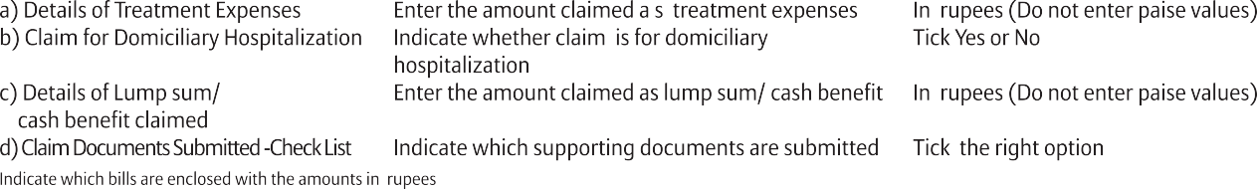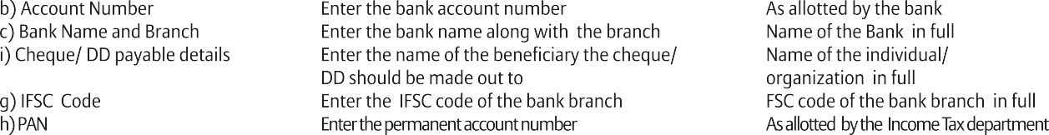

|  |  |  |
| --- | --- | --- |
|  | | |
|  |  |  |
|  |  |  |
|  |  |  |
|  |  |  |
|  |  |  |
|  |  |  |
|  | | |
|  |  |  |
|  |  |  |
|  |  |  |
|  |  |  |
|  |  |  |
|  |  |  |
|  | | |
|  |  |  |
|  |  |  |
|  |  |  |
|  |  |  |
|  |  |  |
|  |  |  |
|  |  |  |
|  |  |  |
|  |  |  |
|  | | |
|  |  |  |
|  |  |  |
|  |  |  |
|  |  |  |
|  |  |  |
|  |  |  |
|  |  |  |
|  |  |  |
|  |  |  |
|  | | |
|  |  |  |
|  |  |  |
|  |  |  |
|  |  |  |
|  | | |
|  | | |
|  |  |  |
|  |  |  |
|  |  |  |
|  |  |  |
|  |  |  |
|  | | |

**Bajaj Allianz General Insurance Co. Ltd.**



Bajaj Allianz House, Airport Road, Yerwada, Pune – 411006. Reg.: 113 | CIN: U66010PN2000PLC015329 For more details, log on to : [www.bajajallianz.com](http://www.bajajallianz.com/)

**Email id:** [customercare@bajajallianz.co.in,](mailto:customercare@bajajallianz.co.in) **Toll free no.** 1800-209-5858, 020-30305858

### CLAIM FORM- PART B

TO BE FILLED IN BY THE HOSPITAL

The issue of this form is not to be taken as admission of liability

Please include the original preauthorization request form in lieu of PART-A (To be filled in block letters)

**DETAILS OF HOSPITAL**

1. Name of the hospital : Chaitanya Hospital
2. Hospital ID : c) Type of hospital : Network Non-Network (If non-network fill section E)
3. Name of treating doctor:
4. Qualification: f) Registration No with State Code g) Phone No:

h) Rohini Code i) NABH CODE j) State Level Certificate

1. Higher Level Certificate l) National Quality Assurance Standards m) National Health System Resource Center

**DETAILS OF THE PATIENT ADMITTED**

1. Name of the patient : Patoju Giri Venkata Naga Sai Dileep
2. IP registration Number : 00408 c) Gender: Male Female d) Age :29 Years 2Months: e) Date of birth:

|  |  |  |  |  |  |
| --- | --- | --- | --- | --- | --- |
| 0 | 7 | 1 | 1 | 9 | 4 |

1. Date of admission: g) Time : h) Date of discharge : i) Time:

|  |  |  |  |  |  |
| --- | --- | --- | --- | --- | --- |
| 0 | 8 | 0 | 1 | 2 | 4 |

|  |  |  |  |  |
| --- | --- | --- | --- | --- |
| 0H | 9 |  | 3M | 0 |

|  |  |  |  |  |  |
| --- | --- | --- | --- | --- | --- |
| 1 | 0 | 0 | 1 | 2 | 4 |

|  |  |  |  |  |
| --- | --- | --- | --- | --- |
| 1H | 111 |  | 1M | 1 |

j) Type of Admission : Emergency Planned Day Care Maternity k) If Maternity i) Date of delivery ii)Gravida Status:

|  |  |  |  |  |  |
| --- | --- | --- | --- | --- | --- |
| D | D | M | M | Y | Y |

l) Status at time of discharge: Discharge to home Discharge to another hospital Deceased: m) Total claimed Amount: 8 9 9 5

**DETAILS OF AILMENT DIAGNOSED (PRIMARY)**

1. ICD 10 Codes Description
   1. Primary Diagnosis:
   2. Additional Diagnosis:
   3. Co-morbidities :
   4. Co-morbidities :
2. ICD 10 PCS Description
   1. Procedure 1:
   2. Procedure 2:
   3. Procedure 3:
   4. Details of

Procedure:

1. Pre-Authorization Obtained: Yes No e) Pre-Authorization Number:
2. If authorization by network hospital no obtained, give reason:
3. Hospitalization due to injury: Yes No i)If Yes give cause: Self-inflicted: Road Traffic Accident: Substance abuse/ alcohol consumption:
4. If injury due to Substance abuse/alcohol consumption, Test conducted to establish this: Yes No (If Yes attach reports) iii)Medico Legal: Yes No iv)Reported to Police: Yes No v) FIR no: vi) if not reported to police give reason:

**CLAIM DOCUMENTS -CHECK LIST**

Claim form duly signed

Original Pre-Authorization request Copy of Pre-Authorization letter

Copy of photo ID card of patient verified by hospital Hospital discharge summary

Operation theatre notes Hospital main bill Hospital break up bill

Ingestion reports

CT/MR/USG/HPE investigation report Doctor's reference slip for investigation ECG

Pharmacy bills

MLC report & Police FIR

Original death summary from hospital where applicable Any other, please specify

**ADDITIONAL DETAILS IN CASE OF NON NETWORK HOSPITAL (ONLY FILL IN CASE OF NON NETWORK HOSPITAL)**

SECTION A

SECTION B

SECTION C

SECTION D

SECTION E

SECTION F

a) Address of hospital City: State: Pin Code: Phone No: c) Registration no with State Code:

d) Hospital PAN: e) Number of Inpatient beds: Facilities available in hospital: i) OT: Yes No ii) ICU: Yes No

1. Others:

**DECLARATION BY THE HOSPITAL: (PLEASE READ VERY CAREFULLY)**

We hereby declare that the information furnished in the Claim Form is true and correct to the best of our knowledge and belief. If we have made any false and untrue statement, suppression or concealment of any material fact, our right to claim under this claim shall be forfeited.

Date :

|  |  |  |  |  |  |
| --- | --- | --- | --- | --- | --- |
| 2 | 8 | 0 | 1 | 2 | 4 |

Place : Narsapuram

Signature and Seal of the Hospital Authority

|  |  |  |
| --- | --- | --- |
| **GUIDANCE FOR FILLING CLAIM FORM - PART B (To be filled in by the hospital)** | | |
| **DATA ELEMENT** | **DESCRIPTION** | **FORMAT** |
|  | **SECTION A - DETAILS OF HOSPITAL** |  |
| a) Name of Hospital | Enter the name of hospital | Name of hospital in full |
| b) Hospital ID | Enter ID number of the hospital | As allocated by TPA |
| c) Type of Hospital | Indicate whether in network or non network hospital | Tick the right option |
| d) Name of Treating doctor | Enter the name of treating doctor | Name of doctor in full |
| e) Qualification | Enter the qualification of treating doctor | abbreviations of educational  qualifications |
| f) Registration No with state code | Enter the registration no of treating doctor  along with state code | As allocated by the medical  council of India |
| g) Phone No | Enter the phone no of doctor | Include STD code with telephone number |
| **SECTION B - DETAILS OF THE PATIENT ADMITTED** | | |
| a) Name of the patient | Enter the name of hospital | Name of hospital in full |
| b) IP Registration number | Enter the insurance provide registration number | As allocated by the insurance provide |
| c) Gender | Indicate Gender of the patient | Tick Male or Female |
| d) Age | Enter age of the patient | Number of years and months |
| e) Date of Birth | Enter date of admission | Use dd-mm-yy format |
| f) Date of Admission | Enter date of admission | Use dd-mm-yy format |
| g) Time | Enter date of admission | Use hh:mm format |
| h) Date of Discharge | Enter date of discharge | Use dd-mm-yy format |
| i) Time | Enter time of discharge | Use hh:mm format |
| j) Type of Admission | Indicate type of admission of patient | Tick the right option |
| k) If Maternity |  |  |
| Date of Delivery | Enter Date of Delivery if maternity | Use dd-mm-yy format |
| Gravida Status | Enter Gravida status if maternity | Use standard format |
| l) Status at time of discharge | Indicate status of patient at time of discharge | Tick the right option |
| m)Total claimed amount | Indicate the total claimed amount | In rupees (Do not enter paise values) |

**SECTION C - DETAILS OF AILMENT DIAGNOSED (PRIMARY)**

|  |  |  |
| --- | --- | --- |
| a) ICD 10 Code |  |  |
| Primary Diagnosis | Enter the ICD 10 Code and description of the primary diagnosis | Standard Format and Open text |
| Additional Diagnosis | Enter the ICD 10 Code and description of the additional diagnosis | Standard Format and Open text |
| Co-morbidities | Enter the ICD 10 Code and description of the co-morbidities | Standard Format and Open text |
| b) ICD 10 PCS |  |  |
| Procedure 1 | Enter the ICD 10 PCS and description of the first procedure | Standard Format and Open text |
| Procedure 2 | Enter the ICD 10 PCS and description of the second procedure | Standard Format and Open tex |
| Procedure 3 | Enter the ICD 10 PCS and description of the third procedure | Standard Format and Open text |
| Details of Procedure | Enter the details of the procedure | Open text |
| c) Pre-authorization obtained | Indicate whether pre-authorization obtained | Tick Yes or No |
| d) Pre-authorization Number | Enter pre-authorization number | As allotted by TPA |
| e) If authorization by network  hospital not obtained, give reason | Enter reason for not obtaining pre-authorization number | Open text |
| f) Hospitalization due to injury | Indicate if hospitalization is due to injury | Tick Yes or No |
| Cause | Indicate cause of injury | Tick the right option |
| If injury due to substance abuse/  alcohol consumption, test conducted to establish this | Indicate whether test conducted | Tick Yes or No |
| Medico Legal | Indicate whether injury is medico legal | Tick Yes or No |
| Reported To Police | Indicate whether police report was filed | Tick Yes or No |
| FIR No. | Enter first information report number | As issued by police authorities |
| If not reported to police,give reason | Enter reason for not reporting to police | Open Text |
| **SECTION D - CLAIM DOCUMENTS SUBMITTED-CHECK LIST** | | |
| Indicate which supporting documents are submitted | | |
| **SECTION E - DETAILS IN CASE OF NON NETWORK HOSPITAL** | | |
| a) Address | Enter the full postal address | Include Street, City and Pin Code |
| b) Phone No. | Enter the phone number of hospital | Include STD code with telephone  number |
| c) Registration No. with State Code | Enter the registration number of the doctor along with  the state code | As allocated by the Medical  Council of India |
| d) Hospital PAN | Enter the permanent account number | As allotted by the Income Tax  department |
| e) Number of Inpatient beds | Enter the number of inpatient beds | Digits |
| f) Facilities available in the hospital | Indicate facilities available in the hospital | Tick the right option. If others,  please specify |
| **SECTION F - DECLARATION BY THE HOSPITAL** | | |
| Read declaration carefully and mention date (in dd:mm:yy format), place (open text) and sign and stamp | | |